
RAMAIAH
Institute of Technology
USN | 1 | M | S

(Autonomous Institute, Affiliated to VTU)
(Approved by AICTE, New Delhi & Govt. of Karnataka) Accredited by NBA & NAAC with ‘A’ Grade

SEMESTER END EXAMINATIONS – JANUARY 2019

Course & Branch | : | B.E: Electrical and Electronics Engineering | Semester | : | VII
Subject | : | Power Systems - II | Max. Marks | : | 100
Subject Code | : | EE72/EE702 | Duration | : | 3 Hrs

Instructions to the Candidates:
- Answer one full question from each unit.

 |  | UNIT- I
1. | a) | Why Y_{BUS} is preferred for load flow studies over Z_{BUS}? Derive an expression for the Y_{BUS} using singular Transformation method. | CO1 | (06)
 | b) | For the systems shown in the Fig1.(b) construct Y-Bus by singular transformation method. The parameters of the various elements are given in the table 1.b. Take node 6 as reference.  Table 1.b  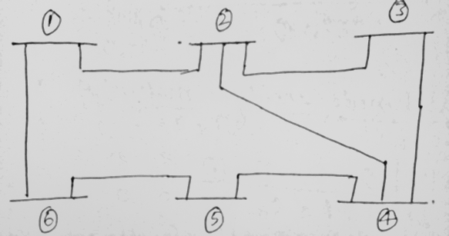  Fig 1.(b) | CO1 | (08)
  Element | From–To Bus | Reactance in Pu.
  1 | 1-2 | 0.04
  2 | 1-6 | 0.02
  3 | 2-4 | 0.03
  4 | 2-3 | 0.02
  5 | 3-4 | 0.08
  6 | 4-5 | 0.06
  7 | 5-6 | 0.05
 | c) | For the graph shown below in Fig 1.c with element 5 and 3 as links. Verify the following relations.  (i) A_{B}*K^{T}= U (ii) B_{L}=A_{L}* K^{T}  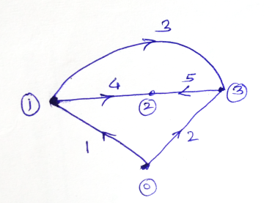  Fig 1.(c) | CO1 | (06)
2. | a) | Write the Z_{bus} after adding branch 1 and 2 in the following network shown in Fig 2.(a) using Z_{bus} building algorithm. Branch 1 is connected between bus1 and 2.Branch 2 is connected between bus 1 and 3. Bus 1 is grounded and is the reference bus. 2Ω is the resistance of each branch.  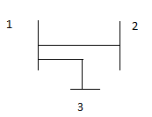  Fig 2.(a) | CO1 | (06)
 | b) | With neat sketch Model the 𝜋-equivalent circuit of transformers with off-nominal turns ratio used in formation of bus admittance matrix. | CO1 | (08)
 | c) | What are primitive element and primitive network? Explain with example. | CO1 | (06)
 |  | UNIT- II
3. | a) | The line data and bus data of a 3-bus system is given below:  Line data  Bus data  Write the equations to be solved for the load flow solution using GS method. Obtain the voltages at the three buses at the end of one iteration using GS algorithm. | CO2 | (10)
  Line | Impedance  (pu)
  1-2 | j0.1
  1-3 | j0.2
  2-3 | J0.2
  Bus | PG(pu) | QG(pu) | PL(pu) | QL(pu) | Vsp(pu)
  1(slack) | - | - | - | - | 1.0
  2(PV) | 5.3217 | - | - | - | 1.1
  3(PQ) | - | - | 3.6392 | 0.5339 | -
 | b) | In a system with 105 buses, out of which we have 1 slack bus, 20 PV buses and remaining PQ buses, what will be the size of the various Jacobian submatrices to solve using NR method. | CO2 | (04)
 | c) | How are the buses classified for load flow studies? Under what operating constraints is the load flow solved? | CO2 | (06)
4. | a) | The bus admittance matrix of a 3-bus system is given by  Ybus =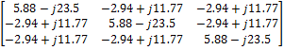 pu.  Bus 1 is slack bus and. Bus 2 is a PQ bus, with a generator connected; Generator power = 0.5+j1.0Pu. Bus 3 is a PV bus; A load of 1.5 + j 0.6 pu is connected at bus 3. Solve for the voltages using NR method, for one iteration. | CO2 | (10)
 | b) | Discuss the equations to be solved using GS method for a PV bus. What is acceleration factor and how does it affect the convergence. | CO2 | (05)
 | c) | Justify the validity of decoupling the load flow equations. Derive the equations to be solved using fast decoupled method. State the assumptions made. | CO2 | (05)
 |  | UNIT- III
5. | a) | With neat figures, explain the performance curves of generating unit. | CO3 | (08)
 | b) | Fig Q.5(b) shows a system having two plants 1 and 2 connected to buses 1 and 2 respectively. There are two loads and a network of four branches. The reference bus with voltage of 1.0<0⁰pu shown on the diagram. The branch currents and impedances are as given. Calculate the loss formula coefficients of the system in pu and in reciprocal megawatts, if the base is 100 MVA.  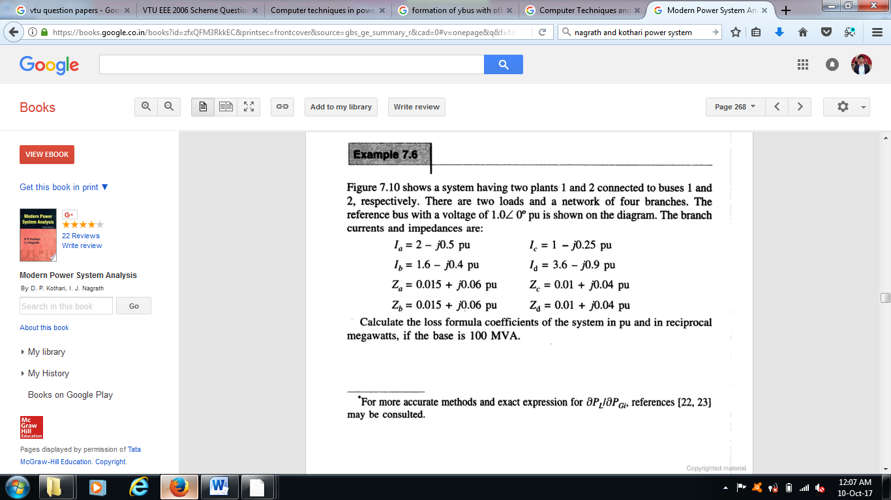  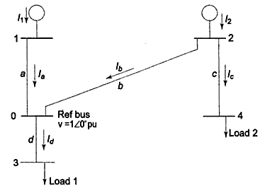  Fig Q.5(b) | CO3 | (08)
 | c) | Distinguish between the problem of unit commitment and economic dispatch. | CO3 | (04)
6. | a) | What are transmission line loss coefficients? Derive an expression for transmission loss as a function of plant generation for a two plant system. | CO3 | (10)
 | b) | The fuel inputs per hour of plants 1 and 2 are given as  F₁= 0.2 P²₁+40P₁+120 Rs/hr  F₂= 0.25 P²₂+30P₂+150 Rs/hr  Determine the economic operating schedule and the corresponding cost of generation, if the maximum and minimum loading on each unit is 100MW and 25MW. The demand is 180MW and transmission losses are neglected. If the load is equally shared by both the units, determine the saving obtained by loading the units as per equal incremental production cost. | CO3 | (10)
 |  | UNIT- IV
7. | a) | Illustrate clearly the method of solving swing equation using Runge-Kutta approach for transient analysis of a power system. | CO4 | (10)
 | b) | With the help of algorithm, explain the modified Euler method for transient stability studies. | CO4 | (10)
8. | a) | For the swing equation, .Calculate δ and ω after 0.05sec by taking a step by 0.05sec. Given δ₀=0.756, ω₀=2.067. Use Runge-Kutta method. | CO4 | (10)
 | b) | Explain Milne’s predictor corrector method for solving swing equation. | CO4 | (10)
 |  | UNIT- V
9. | a) | Obtain the complete block diagram of the load frequency control for an isolated generator supplying a load. | CO5 | (10)
 | b) | Explain the use of capacitors for series and shunt compensation. Discuss the applications of series and shunt connections. | CO5 | (05)
 | c) | Draw a three phase voltage source converter and mention its application in compensation. | CO5 | (05)
10. | a) | Draw the schematic diagram of the governor and explain the speed governor components. Obtain the transfer function for the governor. Draw the governor characteristics and justify the need for droop. | CO5 | (10)
 | b) | What are the advantages of FACTS? Discuss the popular FACTS devices and their applications. | CO5 | (10)

****************

